**SERI-QC USER Guide**

# Installing SERI-QC

* Save the setup directory in any desired location.
* And open SERI-QC.exe file to launch the application.

## **Input Data Format**

The input data must be in a specific format, as shown in Table 1. The format provides for comma delimiters between values. The format is not stringent to any particular column name.

**Table 1.**

|  |  |
| --- | --- |
| Columns | Description |
| 1 | Date in MM/DD/YY format |
| 2 | Time in HH: MM: SS format |
| 3 | Global horizontal irradiance in W/m2. Missing data are indicated by a value > 8000. |
| 4 | Direct normal irradiance in W/m2. Missing data are indicated by a value > 8000. |
| 5 | Diffuse horizontal irradiance in W/m2. Missing data are indicated by a value > 8000. |

*All time stamps are in local standard time (no adjustment for daylight savings time) and must represent the *ending* time of the integration period.

Example Input Records

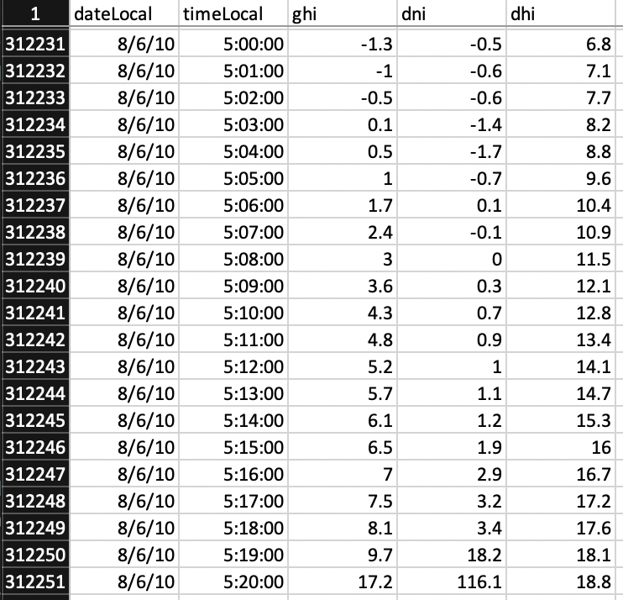

# Working with the Samples

Double-click the SERI-QC icon. You should see the prompt for *.QC0 file.

Navigate to the Sample folder in your SERI-QC directory and select s_BMS.QC0 file. After providing *.QC0 file there will be another prompt for data file.

Navigate to the Sample folder in your SERI-QC directory and select Sample_data_BMS.csv file. After providing the data file there will be another prompt for data acquisition details.

Provide the answers for these data acquisition questions and hit submit. After this user will be prompted for elevation if not provided in *.QC0 file or if the value for elevation is 0 in *.QC0 file. Providing elevation is a mandatory step if prompted.

Now Sit back and let the application do the job. Data assessment and reporting process is initiated now. As soon as this process is done application will show the path where output files are created.

**Understanding the OUTPUT files**

There are 4 output files:

1. Final output *.csv file: This contains all the raw calculations.
2. Refined output *.csv file: This contains timestamp, ghi, dni, dhi and respective flags.
3. Graph *.png file: PNG image of cylinder plot.
4. Report *.html file: HTML report for the assessment

**Glimpse of Refined *.csv and Report files:**

**NOTE:**

With beta release the console is left on intentionally. When you start the application, this console will automatically open and remain alive in the backend. In case of any glitch please take a screenshot and share with us.